**Complete the following turtle program:**

import turtle  
  
turtle.penup()  
turtle.goto(-100,0)  
turtle.color("red", "yellow")  
turtle.begin_fill()  
turtle.forward(300)  
turtle.right(160)  
turtle.forward(100)  
turtle.end_fill()  
turtle.penup()  
turtle.goto(-150, 150)  
turtle.pendown()  
turtle.color("black", "green")  
turtle.begin_fill()  
turtle.circle(45)  
turtle.end_fill()

turtle.done()

1. Right now the funny face has only one eye. Draw another eye. Place it so that the triangular lip is in between two eyes.
2. Position the turtle appropriately and draw a circle around these two eyes and the lip. The output should look like this.

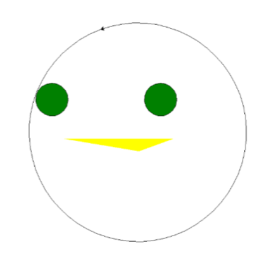

**Extra challenge:**

Using turtle graphics draw a stick figure. Ask the user how many eyes they want and draw that many eyes in the head of your stick figure. This can be solved by using for loop and or if/else statements.